|  |  |
| --- | --- |
| **General consideration** | |
| Data set to present | * What are the relation between the data and purpose * Which data represent on which graph?   7 out of 20 , why? |
| What visualization method to use  (chart 1, 2) | * Which chart to use   Collect during meeting   * Data dimension? * What are the purpose(target)? Does it match the function of the chart? |
| **Jacques Bertin** | |
| Location variable | Location of the graph  - Base on the data set  - Data importance |
| Retinal variables | Size, shape, color (hue, value), texture, orientation  - Base on the data set  - Data importance |

1. The specific design decision need to make (e.g. which graph & which task) (~20 words)
2. State the decision made for system A/B/C (~10-20 words per system)

|  |  |  |
| --- | --- | --- |
| **System A** | **System B** | **System C** |
|  |  |  |
| Description | Description | Description |

1. Describe the alternative designs (use either matrix , or parallel coordinate) (**~ 50 words**)

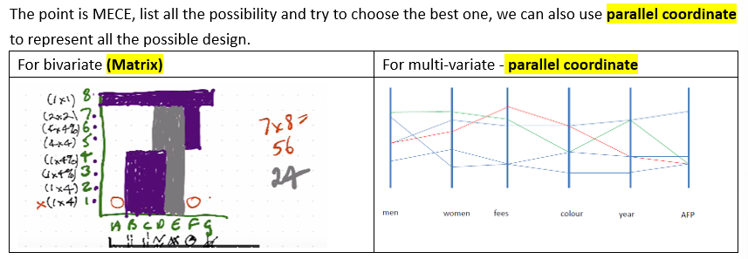

1. Which is best and **why (~ 50 words)**

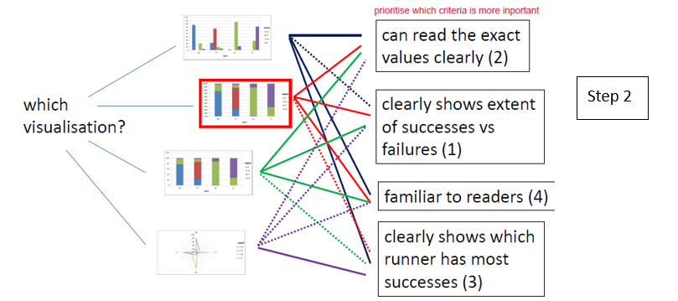

1. Support with diagram and make label on it.